65th URBANNA OYSTER FESTIVAL
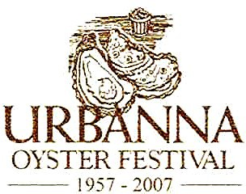
November 4 and 5, 2022

URBANNA OYSTER FESTIVAL PARADE ENTRY FORM SATURDAY, NOVEMBER 5, 2022 at 2:00 P.M.
Sponsored by:

NAME OF GROUP:

NAME OF OFFICIAL IN CHARGE:

MAILING ADDRESS: CITY: STATE: ZIP:

RETURNING PARTICIPANT: NEW PARTICIPANT:

E-MAIL:____________________________________________________________________________________________________________
*Please send a photograph of your group. Your photos may be used for publicity. All new entries MUST submit a photograph with entry form. DAY/EVENING PHONE: CELL PHONE:

TYPE OF ENTRY:
Please include number in group(s). | Quantity: |  | Quantity:
BAND |  | SPECIALTY UNIT
MAJORETTE / MARCHING UNIT |  | QUEEN(S)
CLOWN |  | FLOAT - Size:
 |  | OTHER - Size:
→ NO objects are to be thrown from any parade vehicle, floats or marchers. NO stopping along parade route. Air cannons, loud explosive devices and other objects are prohibited. Current political campaign candidates are NOT permitted in the parade or along the parade route, nor do we allow any political advertisements or promotional materials in the parade. Please Keep in Mind this is a Family-oriented event and parade. We are a Virginia Green Festival.

BRIEF DESCRIPTION OF PARADE ENTRY:
APPROXIMATE NUMBER IN GROUP: *We reserve the right to accept or decline the number of units per entry.
ARE YOU PARTICIPATING IN THE PARADE COMPETITION? YES, IN COMPETITION NO, NOT IN COMPETITION
→ Entry Form must be returned NO LATER THAN SEPTEMBER 16, 2022. Upon approval, you will receive a detailed parade information packet in October 2022. If you have any questions, please call the Festival office at 804-758-2122. Please return completed form to:

Mail: Urbanna Oyster Festival Parade, Drawer C, Urbanna, VA 23175
E-mail: oysterfestival@va.metrocast.net

Thank You for your support of the Urbanna Oyster Festival.

